PROPER USE OF FILLET WELD GAUGES

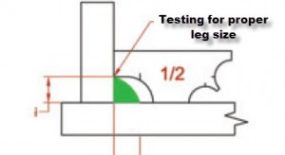
Example of properly sized 1/2″ fillet weld
The illustrations above show you how to test a 1/2″ fillet. Slide the gage and have the top end rest against the vertical piece. This end should be exactly at the top edge of the weld to be a 1/2″ fillet. If there is space between the gage and the toe of the weld then the weld is undersized. The bottom edge of the fillet has more room. This is to allow for a larger leg size. This is sometimes useful with big fillet welds were gravity will tend to make the bottom leg larger. The vertical line will show where the bottom toe should be.
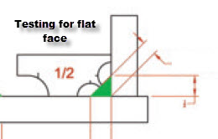
Once we have determined that our weld is properly sized at 1/2″ we test for concavity/convexity. As a general rule of thumb fillet welds should never be concave. The protrusion in the middle of the gage should make contact with the weld – this verifies that the weld is not concave. If there is daylight between the face of the weld and this end of the gage then our weld is concave and no longer an acceptable 1/2″ fillet.
Below are examples of welds that were supposed to be 1/2″ but ended up being undersized and convex.
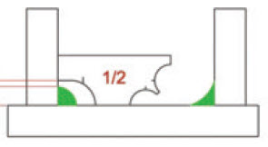
Fillet weld was supposed to be 1/2″ but fillet gage shows it is undersized
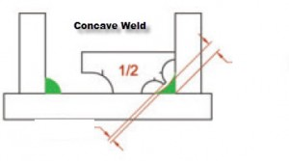
This weld may have measured at 1/2″ but has a concave face making it an unacceptable 1/2″ fillet

